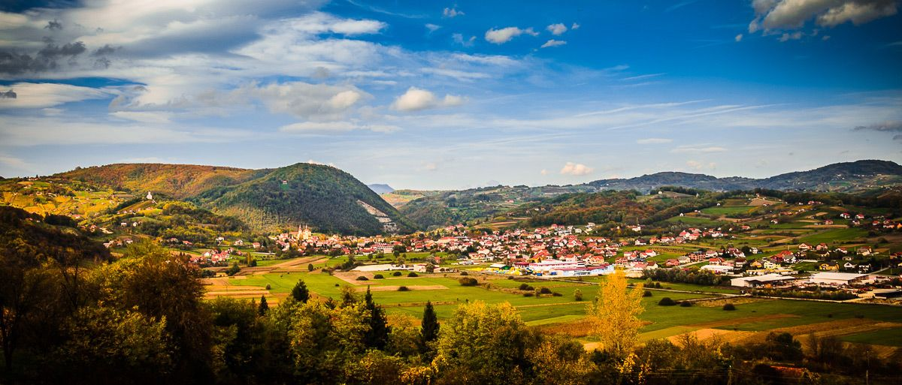
Volunteering CITIES Transfer Networks
CITY OF PREGRADA TRANSFER PLAN

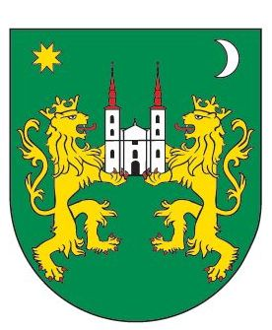
Content
1. STARTING POINT 3
1.1 Brief description of the good practice 3
1.2. PREGRADA position in relation to the good practice 5
Assets and barriers the city brings to the transfer process 6
2. HOW WE ARE GOING TO DO THIS 9
2.1. Our transfer methodology 9
2.2. PREGRADA TRANSFER NETWORK JOURNEY 12
2.3. WHO IS ROUND OUR TABLE? 16
2.4. YOUR CITY’S CONTRIBUTION AND ADDED VALUE 19
2.5. RESOURCES 19
3. THE TRANSFER POTENTIAL OF THE GOOD PRACTICE IN OUR CITY 20
3.1 The transfer potential of the good practice 20
3.2. OUR GOOD PRACTICE TRANSFER EXPECTATIONS 22

Volunteering Cities- City of Pregrada

1. STARTING POINT

1.1 Brief description of the good practice

Municipality of Athienou, Cyprus is the Lead Partner of our URBACT III Network named “Volunteering Cities”. Athienou has a highly functioning society and it represents a role model in providing a real self organised citizenship scheme aiming social inclusion and reduction of poverty.
The city of Athienou (CY) was awarded the URBACT Good Practice Label in 2017 (http://urbact.eu/volunteering-council).
Include video: https://www.youtube.com/watch?v=DB92FDYDYdU
Athienou has, since 1974, a special status with its urban area within the buffer zone controlled by the United Nations and with 80% of its rural area under Turkish occupation. This situation creates a difficult accessibility and, consequently, isolation. Many people were in need to restart their lives and volunteerism was one of the main tools used to forge and sustain social integration and as a result to achieve social development and growth.
Athienou today has a highly functioning society because its particular situation reinforced the territory social cohesion that was already a tradition. The established MCV was a great opportunity to develop further the solidarity through an intensive volunteerism practice, giving Athienou a real self-organised citizenship scheme aiming social inclusion and reduction of poverty.

The core element of the Athienou’s Good Practice is MCV- The Municipal Council of Volunteerism.
The Athienous MCV is integrated under the National Coordinating Committee for Volunteerism. The entire institutional structure is supported by Welfare Office, Ministry of Labour and Social Insurances. Despite the institutional structure, the MCV has a very high degree of autonomy in deciding and implementing actions. The integration with national authorities provides support, standards, monitoring and auditing services, and additional resources.
The members of the MCV understand the aim of the Council mainly based on three big objectives:
- To identify the social problems of the city by collecting information from various sources
- To find solutions for the problems,
- To raise the necessary funds to implement the solutions.
Due to the composition of the MCV there is a wide range of possibilities of mapping the social problems namely through the teachers and the social workers. Athienou is a small city with a big tradition in solidarity among its members since everybody knows each other. Already in the old days the families joined together to help each other building their houses. There is a high engagement of people in the MCV activities and the fact that the Committee is elected reinforces the legitimacy and acceptance of its members. The bishop of the region (13 municipalities) has stated: “Athienou has the most intensive solidarity in the region”.
The MCV operates four programs, all of them in the Municipal sphere:
- the “Kleanthios Elderly House” (established in 1983),
- the “Konstanileneion Center for Adults” (established in 2001);
- the “Municipal Nursery Center” (established in 1991); and
- the Social Welfare Committee (established in 2012).
Each member of the community can be a volunteer and take part in the Volunteering actions approved by the MCV. Volunteers declare their participation interest either towards the programs or the MCV itself.
The MCV uses a bottom-up approach promoting vertical and horizontal integration allowing volunteers to take decisions but within structures closely related to the Municipality itself.
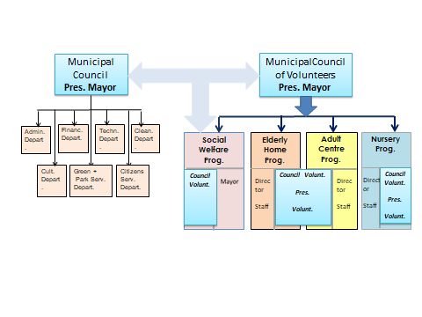

1.2. PREGRADA position in relation to the good practice

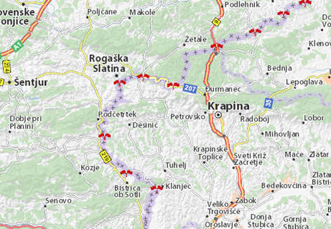
Pregrada is a city/municipality in Krapina-Zagorje County in Croatia. Krapina-Zagorje County is located in northwestern Croatia, bordering Slovenia. It encompasses most of the historic region called Hrvatsko Zagorje.
It has 6.594 habitants and a surface of 67,2551 km2.

The Municipality has the responsibility of solving social challenges that are addressed in the community. The GP can support already existing systematization of the work that has been developed in the social area of the city. However, transfer of the GP will contribute to create more participatory model of work in the social area that will involve several social groups of the community and several areas of knowledge. It will be fundamental to create the conditions for a more active, and, above all, more organized volunteering work
In this context the City of Pregrada wants to transfer following transfer modules:
M1 Governance participation
According to this representative module we want to create board similar to Athienou MCV that will be able
- to identify the social problems of the city by collecting information from various sources | - To find solutions for the problems | - To raise the necessary funds to implement the solutions.
However, for the sustainability of its work we will have to ensure financial and human resources and also the political support.
Due to the composition of the board we will have to ensure participation of volunteers in board, especially young ones and also representatives of local and regional companies.
We want to create a coordination and collaboration mechanisms in order to improve the efficiency of the use of resources as well as to cover wider ranges of complementary services. In accordance to this we have to increase involvement of citizens and institutions in co-developing poverty and social inclusion policies of our community. The important thing is promotion of common goals and activities that reinforce the social cohesion.
With all this having we can increase the number of services being provided to the population, especially those that are in need, without increasing the financing burden of the social protection policies.

M2 Intergenerational cohesion  According to this representative module we want to: | M3 Young volunteers  According to this representative module we want to: | M4 Corporate citizenship  According to this representative module we want to:
- to address already existing organizations and institutions that provide activities that address intergenerational cohesion | - to educate young people about benefits of volunteerism | - to involve local and regional companies in city social- local activities
- to address already existing good practice of our local organizations and institutions in this field, | - to educate organizers of volunteering actions | - to coordinate activities and contribution of them to real needs of the community
- to ensure the support for the improvement | - to connect young potential volunteers with local institutions, local government and CSO's
- to bring together individuals of different generations that can learn and share with each other allowing the sustainability of the initiative through the young people and a better quality of life to elderly people | - to make a list of volunteering actions available online to everybody

Assets and barriers the city brings to the transfer process

The work in the Municipality is participative; it is organized through many boards or commissions that are established with stakeholders that support solving of issues which affect citizens quality of life. Through the social networks the City of Pregrada has achieved a high level of transparency and constitutes a good practice in participative processes by involving local people in the work of the local government,
The CITY Social and health program was improved in 2018 with new demographic measures in order to provide support to young families and their children covering the whole territory of the City since most people in risk of poverty and social exclusion are located in rural areas.,
Also the Municipality makes serious investments, namely related with supporting infrastructure and with agricultural production. Development of rural areas is the foundation for young families and their children to make a home and live in good standards. This process contributes to inter-generational cohesion and social inclusion.
There is already existing organizational structure that provides involvement of children and youngs in decision making process – City children Council, Youth Council.

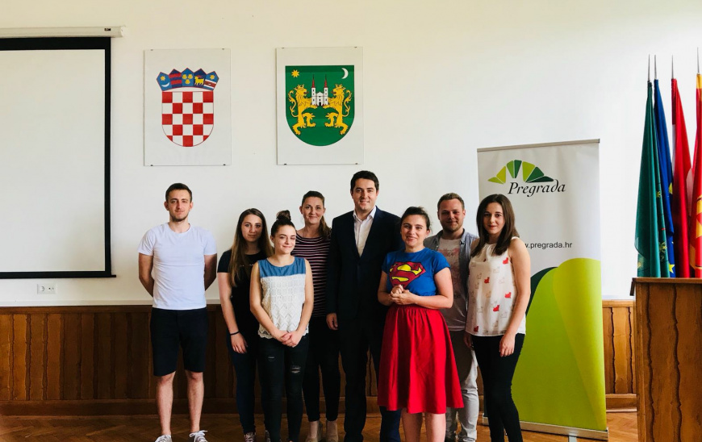
Youth Council 2018.-2021.
Children City Council 2018.-2020.
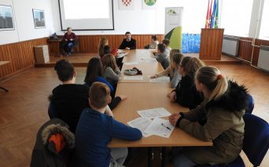

Important fact is that there is more than 60 active CSO's with more 1000 volunteers. City has great collaboration with them, while it provides financial and non- financial support to their work.

ASSETS:
- Already existing cooperation with several stakeholders (CSOs, Red Cross, educational institutions, Social Welfare Centre, regional government, City Youth Council, Children’s City Council)
- Experience in preparation and management of projects (national, international)
- Participative approach followed by the city (cooperation culture)
- One of the most secure cities in Croatia
- work of local government is organized in two departments
- Tourism potential
- Political will to create mechanism of cooperation of all stakeholders that are established to provide social welfare and also educational institutions
- Entrepreneurship has been continuously rising

BARRIERS:
- lack of strategies how to develop social services for those in need as well as to promote social inclusion,
- There is no tradition in volunteering services meaning need of mobilization actions,
- Lack of strategy how to develop social services for those in need,
- Lack of strategy how to provide social inclusion for those in need,
- Lack of strategy how to provide inter- generational cohesion,
- Lack of interest in volunteering , especially among youngs,
- Lack of interest of those in need in providing social inclusion,
- lack of coordination and collaboration of the local institutions and civil society organizations in the process of solving social problems of our community,
- Lack of involvement of local and regional entrepreneurs in dealing with local social challenges.

2. HOW WE ARE GOING TO DO THIS

2.1. Our transfer methodology
The level of transfer potential differs from one partner to another. In the case of Pregrada, it seems realistic to fully transfer some elements of GP, but in some elements we will have kick-start., However, due to the partners profiles, competences and capacities, we are aware that different kind of difficulties can be met and will have to be overcome.
Our Network transfer methodology is based on a Matrix of the GP thematic modules that will be explored by deep dives in each one of the 8 transnational meetings according to the priority Module for the host city. Two additional optional modules will be added according to the interests of the organizing cities.
- 4 Common Modules and 2 Optional Modules (thematic modules are the different elements of the GP)
- 8 transnational Meetings.
The “Volunteering City Network“ has decided for the Carousel Hybrid Transfer Model, covering transnational meetings with all partners in all cities and with bilateral exchanges according to the partly shared transfer elements.

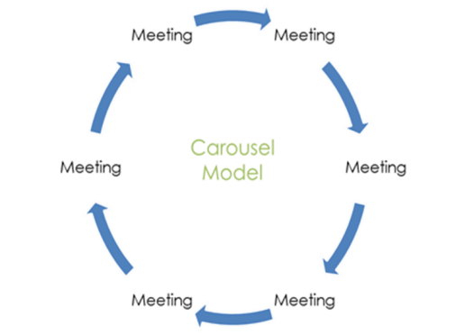

Thematic Transnational Meetings
City of Athienou will firstly be able to enable improvement through the transfer of the entrepreneurship associated to volunteering activities (social economy) and other eventual activities to the seven transfer partner cities. Through the Transnational Meetings, online Bilateral Thematic Meetings and Bespoke Support activities described below, Athienou will be able to share the Good Practice, learn from other partners and improve the Good Practice.

The transfer methodology of the Volunteering Cities GP is based on a Matrix of the GP thematic modules that will be explored by deep dives in each one of the 8 transnational meetings according to the priority Module for the host city. Two additional optional modules will be added according to the interests of the organizing cities.
- 4 Common Modules and 2 Optional Modules (thematic modules are the different elements of the GP)
- 8 transnational Meetings
To achieve our objective of transferring the methodology of Volunteering Cities we will create the Municipal Volunteer Committee (CMV) associated to the local council of social action (CLAS) which will be composed of the members who will be elected by that CLAS.

Thematic Transnational Meetings:
Athienou will firstly be able to enable improvement through the transfer of the entrepreneurship associated to volunteering activities (social economy) and other eventual activities to the seven transfer partner cities. Through the Transnational Meetings, online Bilateral Thematic Meetings and Bespoke Support activities the transfer process will generate co-creation of knowledge and experience. The Transnational Meetings thematic focus is explained in the table below.

Through the URBACT Local Group:
The ULG will be the main implement “instrument” of the Transfer of the Good Practice at the local level.
The whole process will be supported by the LP and the LE namely through bespoke actions (Webex meetings).
0TNM ARCOS | 1 TNM ALTEA |  | 2TNM RADLIN |  | 3TNM PREGRADA |  | 4TNM ALTENA |  | 5TNM ATHY |  | 6TNM CAPIZZI
This meeting was dedicated to observe and explain the Entrepreneurship Initiatives of Arcos (Deep Dive) as a Module that interests especially Athienou, Athy and Capizzi. Moreover, there is a learning exchange on Volunteering principles and actions in Arcos since this is a common Module (Governance Models) to all partners. |  | Will review partner transfer plans. The emphasis of the learning exchange will be upon exploring achievements Module 2 – Promoting Intergenerational actions (deep dive). |  | The emphasis of the learning exchange will be upon exploring achievements Module 1 – Analysis of Governance Models related with Volunteering. (deep dive). |  | The emphasis of the learning exchange will be upon exploring achievements Module 2 – Promoting Intergenerational actions (deep dive). |  | The emphasis of the learning exchange will be upon exploring achievements Module 3 – Promoting Volunteering in Youth generations (deep dive). |  | The emphasis of the learning exchange will be upon exploring achievements Module 2 – Promoting Intergenerational actions (deep dive). |  | The emphasis of the learning exchange will be upon exploring achievements Module 2 – Promoting Intergenerational actions (deep dive).

2.2. PREGRADA TRANSFER NETWORK JOURNEY

So as it is explained in previous section transnational meetings will be our main activity implemented to promote the exchange and learning between the partners. This meeting will provide collaboration and coordination between partner cities and their ULG's on transnational level.
Before and after every TNM there will be one meeting of our ULG. The aim of ULG meetings will be either the preparation for the transnational meetings, or discussion about reports of TNM. It is important to deliver informations from ULG members to other partners and to the Lead expert as well the information from the partners and LE to the ULG members. This will be the link between ULG members and other partners and their ULG members.
At the local level the ULG members will have the tasks to organise and coordinate local activities in order to provide our achieving Modules.
Communication between our ULG members and other cities ULG will be organised if it would be neccessery by skype calls or something similar.

Transfer diary | Treasure Box | Virtual meetings
- Each local event will be followed by a report that documents the activities and the possible feedback from the public | - The stakeholders will be actively involved in the preparation of Transfer stories and vox-pops. The City`s ULG coordinator will study the ULG toolkit and will adopt its standards in ULG meetings and will be in the interaction between local stakeholders and transfer network stakeholders. | - Regular virtual meetings will be organized using adapted tools (Webex) including all city partners and the LE in order to provide a direct and often communication between the members of the network, facilitating also the work during the TNMs.
- The ULG will appoint at least 3 stakeholders to perform entries in the Transfer diary. One stakeholder will be the ULG coordinator, one stakeholder from the Lead Partner, and one stakeholder that represents the local volunteering activities/organisations. | - The City`s ULG coordinator will participate in training provided by the URBACT programme early in 2019. | - There will be a minimum of one virtual meeting including all partners organized between two TNMs.
- Wherever it will be needed, more stakeholders will perform entries in the transfer diary. At least one transfer diary entry will be made after an event organised as part of the activities of the Transfer Network. | - The Athienou ULG is there to provide all the necessary consultation to the Partner Cities and Partner ULGs to achieve the transfer objectives. | - For these meetings more simple tools will also be used, such as Whatsapp, Viber or Skype calls.
 | - Therefore, according to this, when it will be necessary we will have virtual meetings with our Lead Partner and Lead Expert.

CITY OF PREGRADA GANTT CHART – ROADMAP 24 month duration

2019
 | JAN | FEB | MAR | APR | MAY | JUN | JUL | AUG | SEP | OCT | NOV | DEC
TNM`S |  | Arcos de Valdevez 13th-16th | Altea 27th-30th |  |  | Radlin 24th-27th |  |  | Pregrada- HOST, 10th-13th |  |  | Altena
ULG Meetings |  |  | 1 | 1 |  | 1 | 1 | 2 | 2 | 1 | 1 Open ULG MEETING | 1
URBACT Campus |  |  |  |  | 23rd-24th, Novigrad, Croatia
Local activities | 3 | 2 | 2 | 6 | 3 | 1 |  |  | 1 | 1 |  | 4
Web articles |  | 1 | 2 | 6 | 3 | 2 | 1 | 2 | 4 | 2 | 1 | 6
Communication Strategy Implemented
Transfer Diary Entries (TNM, ULG MEETINGS, Local activites) |  | 1 | 1 | 1 |  | 1 |  |  | 1 |  | 1 | 1
Vox Pops |  |  | 1 |  |  |  |  |  | 2
Webinar |  |  | 1
WEBex meetings |  | 1 | 1
Transfer plan creation process | Draft | Draft | Peer review | Final version
2020
 | JAN | FEB | MAR | APR | MAY | JUN | JUL | AUG | SEP | OCT | NOV | DEC
TNM`S |  |  | Athy |  |  | Capizzi |  |  |  |  | Athienou
ULG Meetings | 1 | 1 | 1 | 1 |  | 1 | 1 | 1 | 1 | 1 | 1 Open ULG MEETING | 1
Local activities | 2 | 2 | 1 | 6 | 1 | 1 |  |  | 1 | 1
Web articles |  | 3 | 3 | 6 | 1 | 2 | 1 | 2 | 1 | 2 | 2 | 2
Transfer Diary Entries (TNM, ULG MEETINGS, Local activites) |  |  | 1 | 1 |  | 1 |  |  |  |  | 1
WEBex meetings
Transfer plan implementation
1st progress report | 1
Local/regional event
Final event |  |  |  |  |  |  |  |  |  |  | TNM in Athienou

2.3. WHO IS ROUND OUR TABLE?
The City discovered that the only solution to face the increasing scarcity of resources is to co-share and to co-implement solutions. This was the fundamental reason for the development of stakeholders’ network- our ULG.
In line with the needs key stakeholders addressed in our city are public institutions, civil society organisations, local and regional companies, and local government.
Most of them are already involved in our ULG, but through the work and activities we will address stakeholders that could contribute to this transfer of the Good practice. According to this the full list of stakeholders and ULG members will be a living and growing one, since it will incorporate new actors in the process of transfer.
At this stage, the main stakeholders indentified are as follows:
 |  |  |  | Potential Inputs- Collaboration
 | Name | Profile/Interest |  | Menagment | Other
1. | City of Pregrada | Local government administration, Mayor and other elective representatives- political and administrative support to th project
2. | City of Pregrada Red Cross Association | NGO, very active assosiation in field of intergenerationality
3. | Social Welfare Service- region office in Pregrada | Informations about citizens in need, informations grom the field
4. | “Naša radost” nursery school | 100% publicly owned institution, experience in preparation and implementation EU and national projects in field of education, important for development of tradition of volunteerism among the children
5. | Pregrada Music School | 100% publicly owned institution, important for providing activities that foster intergenerationality
6. | Pregrada Municipal Library | 100% publicly owned institution, experience in preparation of national cultural projects, important for providing activities that foster intergenerationality
7. | Pregrada Municipal Museum | 100% publicly owned institution, experience in preparation of national cultural projects, important for providing activities that foster intergenerationality
8. | Janko Leskovar Elementary School | 100% publicly owned institution, experience in preparation and implementation EU and national projects in field of education, important for development of tradition of volunteerism among the children
9. | Pregrada High School | 100% publicly owned institution, experience in preparation and implementation EU and national projects in field of education, important for development of tradition of volunteerism among the youngs
10. | Pensioners Association | CSO, important for providing activities that foster intergenerationality
11. | Cultural and artistic association Pregrada | CSO, important for providing activities that foster intergenerationality
12. | Sports Community of Pregrada | CSO, important for providing activities that foster intergenerationality
13. | “Our Children” association | CSO, important for providing activities that foster intergenerationality, for providing activities for families and children in need
14. | Children's City Council | Consultative body for providing children rights and their need in the community: children are included in decision making process: configuration: elementary school children from 1st to 7th grade
15. | Network of associations ZAGOR | CSO, important for providing activities that foster volunteerism, experience in preparation and implementation EU and national projects in field of education

 | SH THAT WE NEED TO INVOLVE:
 |  |  |  | Potential Inputs- Collaboration
 | Name | Profile/Interest |  | Menagment | Other
1. | Local or regional companies | Human and financial support, experience in management of the project
2. | All political parties | Wider political support to the project
3. | City council members | Wider political support to the project-elective representatives
4. | City Youth council | Consultative body for providing rights and needs of young people in the community: Through it youngs are included in decision making process: configuration: young citizens year-age: 15 to 30
5. | Other important local organizations (for example; parents associations), | Informations about social challenges they are dealing with, suggestion of solutions
6. | Other important local individuals

2.4. YOUR CITY’S CONTRIBUTION AND ADDED VALUE

In the last few years, through social networks the City of Pregrada has achieved a high range of transparency and constitutes a good practice in participative processes by involving local people in the work of the local government.
The City discovered that the only solution to face the increasing scarcity of resources is to co-share and co-implement solutions. This was the fundamental reason for the development of stakeholders’ networks.
The City of Pregrada was the first in Croatia to implement, with big success, a crowdfunded project. The aim of the project was the renovation of the kindergarten „Naša radost“ Pregrada. This way we offered to the citizens a way to contribute to something that is important for our community and the feedback was great. Our success was more than 100%.
Moreover, citizens are activated by the activities of Civil Society Organisations whose work is done through volunteering and that are funded by the Municipality. This fosters the motivation of the citizens to volunteer for public good and enlarge services provided to the citizens in number and diversity.
We have over 60 active CSO`s with more than 1000 volunteers.

2.5. RESOURCES

We have political will to create a mechanism of cooperation of all stakeholders that are established to provide social welfare and also educational institutions. City Mayor is our huge motivator and our support.
Pregrada's Mayor is a representative in the Croatian Parliament. When he was elected in the Parliament he decided that he will perform his function of the City Mayor as a Volunteer. Through this act he showed his willingness to work on the benefit of his community.
It was crucial not only for promotion of the volunteerism, but also for building a good relationship with the citizens. The aim is to show them that local government is here for them, that we all work for the benefit of our community.
ULG is also a great opportunity to make changes in our City. The ULG members have a will to design a strategy to support social inclusion and intergenerational cohesion, especially addressing disadvantaged groups.
When we see the ULG we see all important stakeholders that can make changes by sitting at one table. All of them are already doing a lot in order to improve quality of life in our City. Furthermore, their willingness to make an improvement in existing model of solving social challenges is very promising.
We think that we have enough of human resources, except when it comes to the youth volunteers. We can say that some changes in our community are visible at the moment, but we need to activate youth members of our community as well as the local entrepreneurs.
We already have some good mechanisms of solving social challenges but we need support of other community members. We need motivation, innovation, strength and willingness that young people can bring to the table from one side and the human resources and support resources that the local entrepreneurs can bring from the other side.
According to the sustainability of the practice that we want to transfer we have to think about financial resources.
Financial resources will be crucial for the implementation of our plans. In accordance to that we are planning to provide some financial resources our city budget, but also donations from the local and regional companies that we will involve in our local network.

3. THE TRANSFER POTENTIAL OF THE GOOD PRACTICE IN OUR CITY

3.1 The transfer potential of the good practice

M1_Participative Governance
At the end of the 24-month duration of the project, we intend to create a Municipal Volunteer Committee that will regulate all municipal volunteer activities and local volunteer practice.
OUTPUT INDICATORS:
- Board similar to Athienou's MCV created in Pregrada
- Financial resources for Board work board available
- All crucial stakeholders and individuals involved at the board
- Have a volunteer fellowship consisting of at least 50 members;
- Have a scholarship of at least 10 volunteer receiving entities;
- To have at least 3 local companies associated to the Volunteer Committee and to provide resources to support their activity;
- At least 3 volunteer programs developed at the local level.
M2_Increase Intergenerationality
At the end of the 24-month duration of the project, we intend to establish coordinated activities that involve youngs and elderly people.

OUTPUT INDICATORS:
- At least 3 existing activities that provide intergenerationality strengthened
- At least 3 new activities that provide intergenerationality established
- Long- term performance of new activities ensured
- Collaboration and cooperation between ULG members and other stakeholders reinforced
- At least 10 youth volunteers reached out
M3_ Mobilize Young Volunteers
At the end of the 24-month duration of the project, we intend to educate and to encourage young volunteers to create new volunteering activities and to take part in existing volunteering activities.
OUTPUT INDICATORS:
- to provide at least 2 education programmes for young volunteers,
- to provide at least 2 education programmes for volunteering action organizers,
- to educate at least 30 youth citizens,
- to educate at least 5 volunteering action organizers,
- to create a database of volunteering activities on city`s web page with application details,
- to promote volunteerism and volunteering actions through social media,
- to reward young volunteers, volunteering actions and volunteering action organizers (once a year),
- to involve young volunteers them in decision making process.
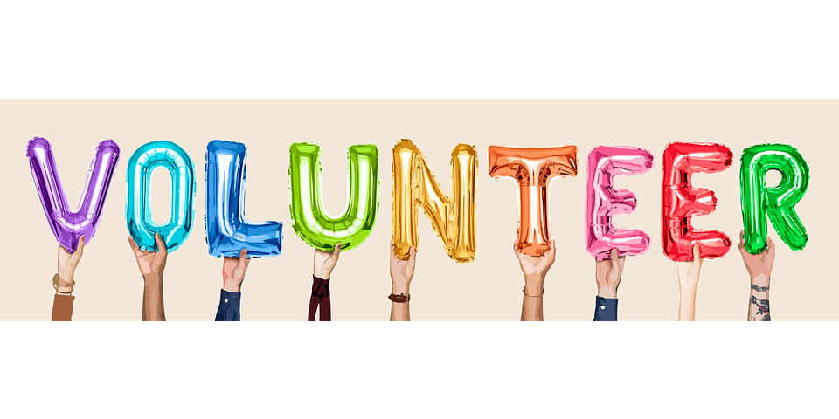
M4_Corporate Citizenship
At the end of the 24-month duration of the project, we intend to ensure participation of local and regional entrepreneurs in dealing with social challenges of our community.

OUTPUT INDICATORS:
- Mapping of all local and regional entrepreneurs done
- to provide at least 1 education programme for local and regional entrepreneurs,
- to involve at least 3 local or regional entrepreneurs in organization and performance of project activities,
- to create labelling system for entrepreneurs that will ensure support to the local community,
- to promote entrepreneurs that will be included in activities.

3.2. OUR GOOD PRACTICE TRANSFER EXPECTATIONS
We are aware that each city represents a unique community, and that we have to adjust Athienou’s good practice to the challenges of our local communities. Through the period of 24 months we will try to transfer all 4 elements (MODULES) of Athienou’s good practice, and also successful practice of our project partners. In some Transfer Modules we are already quite advanced in relation to the good practice; but in others we are going to start from the ground. Also the Good Practices vary in scale and complexity. Some elements can be adapted and transferred more easily than others within our timeframe.
However, we have to be very realistic in our expectations and at this point we have willingness to transfer all modules in 100%. We see this project as an opportunity to make something better for our community, to improve things that we already have and to give a kick- start point to things we do not have.
We have great expectations of what we can achieve within the URBACT Transfer network timescales.

Please address all your questions to marija.marjanovic@pregrada.hr

